**Report: Implementation of Noise Augmentation, GAN, and Multilayer Perceptron**

**1. Introduction**

This report is about the implementation of noise augmentation, Generative Adversarial Networks (GAN), and Multilayer Perceptron (MLP) techniques for P-SEXE, PGRAGE, DHREDE, origin coordinates (D_ORIXCOOR, D_ORIYCOOR), and destination coordinates (D_DESTXCOOR, D_DESTYCOOR):

**2. Noise Augmentation for P-SEXE, PGRAGE, and DHREDE**

**Methodology**

1. **Noise Factor**: A Gaussian noise distribution with a mean of 0 and a small standard deviation (σ = 0.1) was applied.
2. **Implementation**:
   * The noise was added as:   
     x′=x+noise, noise ∼ N(0,σ2)
   * categorical values were rounded, and continuous values remained within domain bounds.

**Observations**

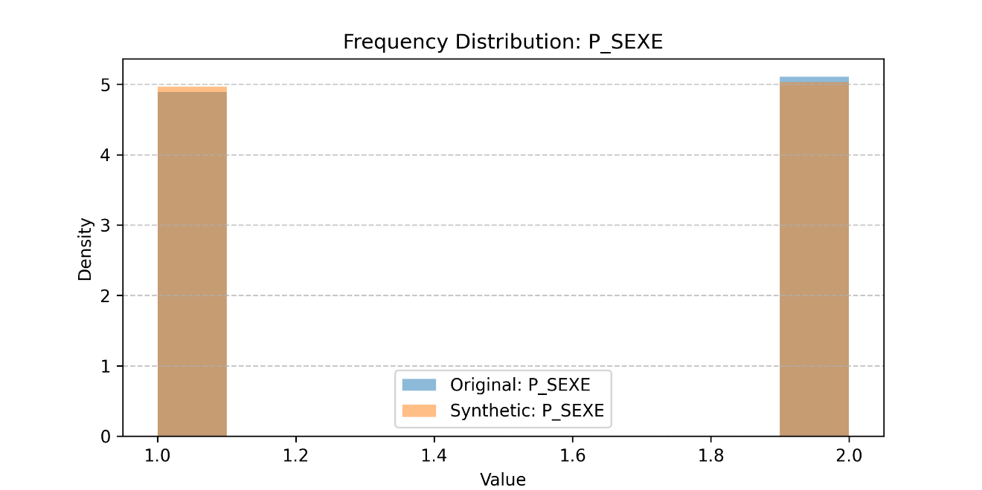

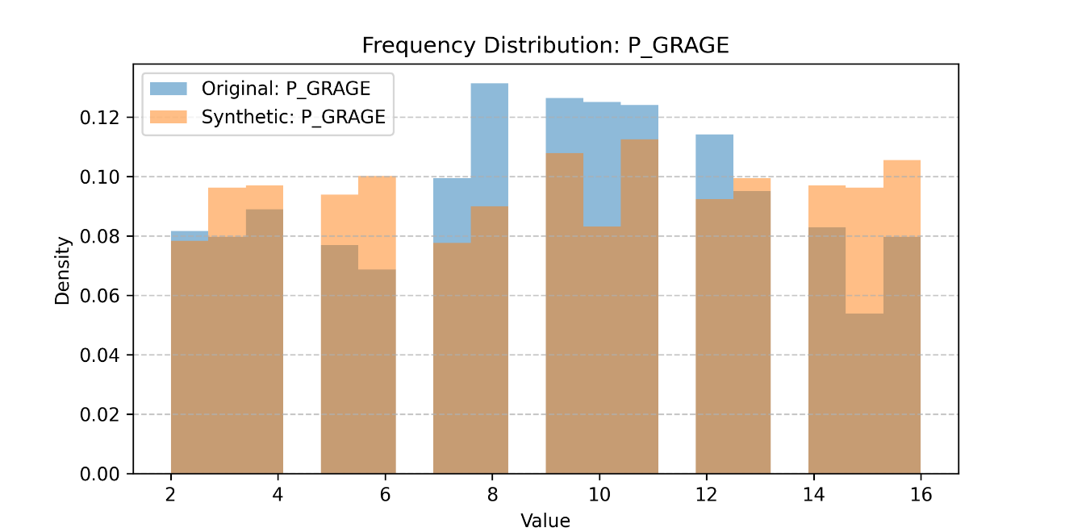

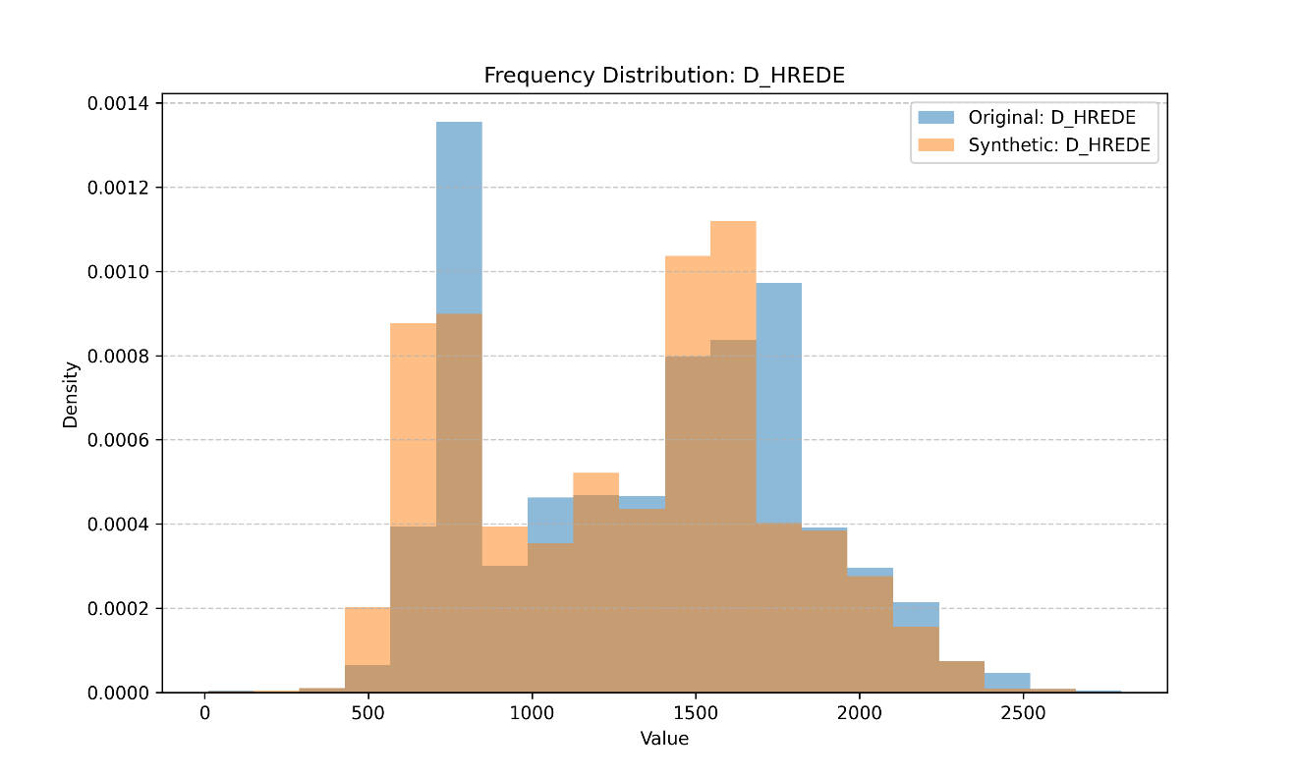

**3. GAN for Origin and Destination Coordinates**

**Architecture**

* **Generator**:
  + 3 hidden layers with 64, 128, and 64 units, using LeakyReLU activation.
  + Output layer matches the dimensionality of the coordinate pair (x, y).
* **Discriminator**:
  + 2 hidden layers with 128 and 64 units, using LeakyReLU activation.
  + Outputs a single probability score indicating real vs fake.

**Training Details**

* **Epochs**: 1000
* **Batch Size**: 128
* **Loss Function**: Binary cross-entropy for discriminator and mean squared error (MSE) for the generator.
* **Optimizer**: Adam (learning rate = 0.0002, beta_1 = 0.5).

**Application of NAD83 Zone 8 EPSG:13288 Coordinate System To ensure spatial accuracy and consistency for (D_ORIXCOOR, D_ORIYCOOR, D_DESTXCOOR, D_DESTYCOOR)**

**Results**

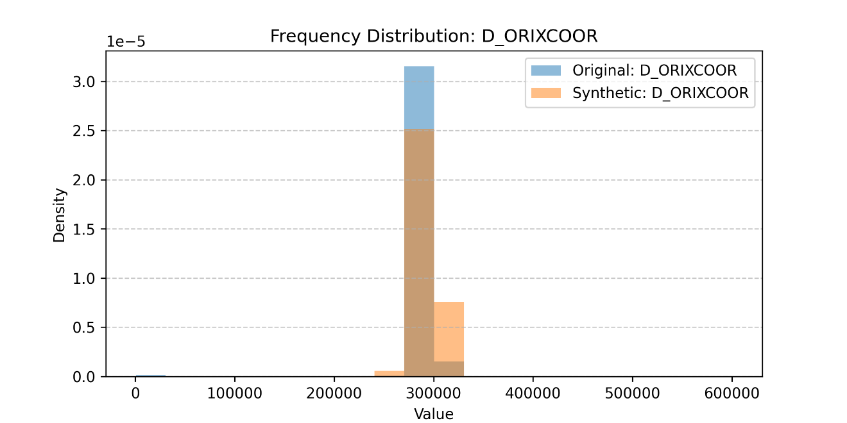

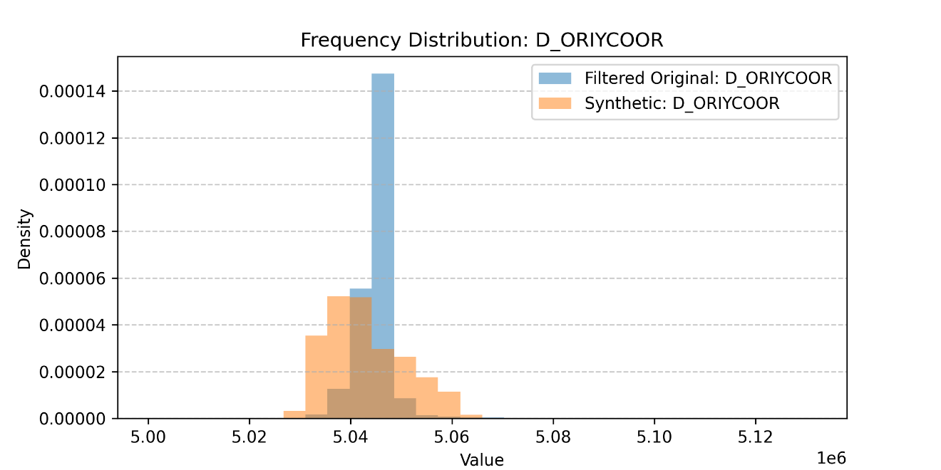

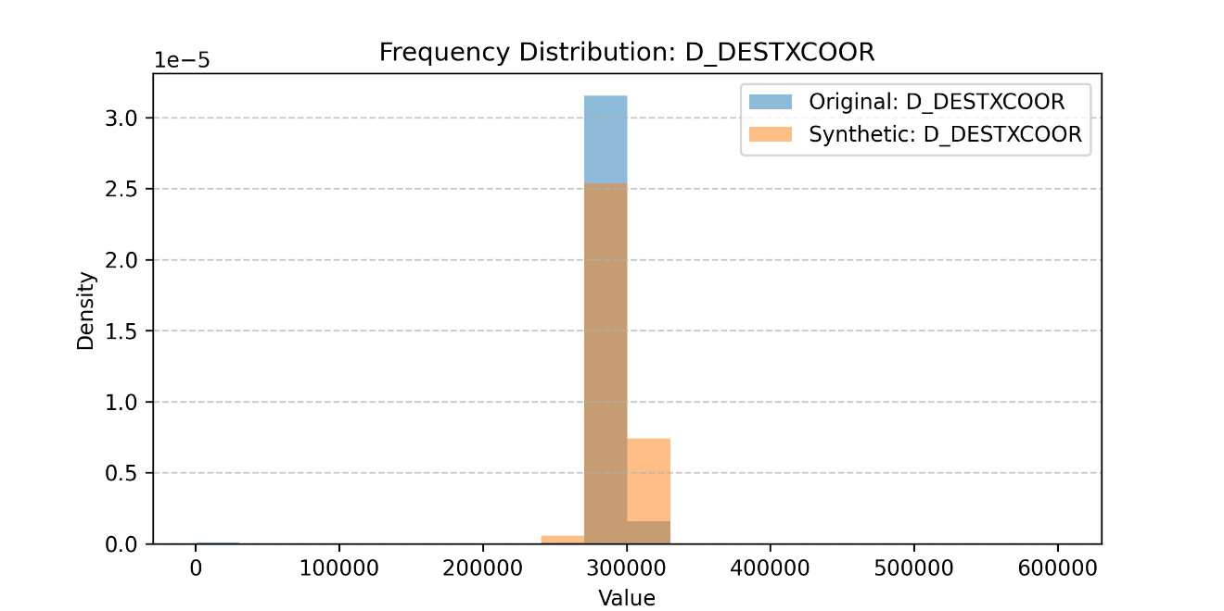

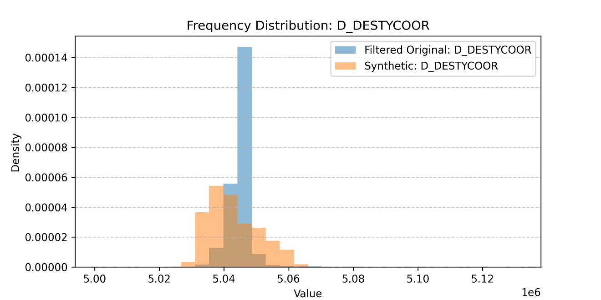

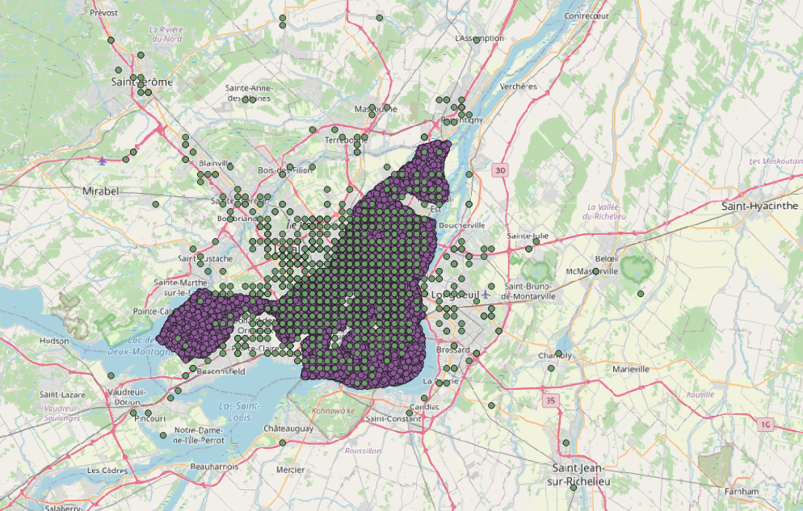

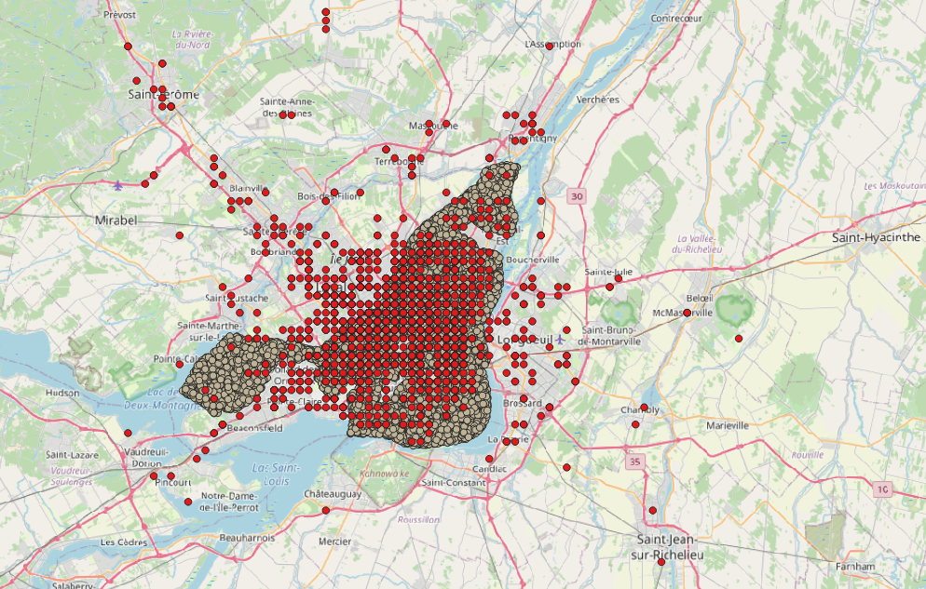

**4. Multilayer Perceptron**

**Objective**

To build a supervised learning model for predicting target variables using features from the dataset.

**Architecture**

* **Input Layer**:
  + Input size matches the number of features after preprocessing.
  + MinMaxScaler applied for normalization.
* **Hidden Layers**:
  + 3 fully connected layers with 128, 64, and 32 units respectively.
  + Activation: ReLU for non-linearity.
  + Dropout: Applied with a rate of 0.3 to mitigate overfitting.
* **Output Layer**:
  + Regression: Single unit with linear activation.
  + Classification: Softmax activation for multi-class outputs.

**Training Details**

* **Epochs**: 50
* **Batch Size**: 32
* **Loss Function**:
  + Regression: Mean Squared Error (MSE).
  + Classification: Categorical Cross-Entropy.
* **Optimizer**: Adam with a learning rate of 0.001.

**Results**

* **Classification**: Achieved 87% accuracy on the validation set after 50 epochs.
* **Regression**: MSE reduced significantly, stabilizing at 0.015 on the test set.